GUEST LIST ORGANIZER
@CREATIVITY THINK (9483175986/7019689991)

ABSTRACT:
Guest List Organizer is a web-based application designed to streamline event planning and guest management. The system allows users to create events, maintain guest lists, track RSVPs, set reminders, and visualize analytics through dashboards. Administrators can manage all events, oversee guest responses, send reminders, and monitor overall participation metrics. Built with Django and Django Rest Framework on the backend and React with recharts and socket.io on the frontend, the platform ensures real-time updates, efficient communication, and seamless management of events for parties, clubs, and social gatherings..

INTRODUCTION OF THE PROJECT:
Managing guest lists and RSVPs manually is often cumbersome and prone to errors, especially for large events. Traditional methods such as spreadsheets or paper-based tracking lack real-time updates and automated notifications. Guest List Organizer addresses these challenges by providing a centralized platform for event creation, guest invitation, RSVP management, and reminders. Users can easily manage attendance, monitor participation trends, and export data. Administrators benefit from dashboards that offer insights into guest engagement, reminders sent, and event analytics, making the platform efficient, reliable, and user-friendly..

PROJECT OBJECTIVES:

• Provide a platform to create and manage events efficiently
• Enable users to maintain guest lists and track RSVPs
• Automate reminders for invited guests
• Allow administrators to oversee events, guest lists, and analytics
• Provide dashboards with visual insights into event participation
• Support real-time updates and notifications using socket.io
• Allow data export for reporting and record-keeping
• Ensure scalability for multiple simultaneous events

PROBLEM OF THE STATEMENT:
Event organizers often face difficulties in managing guest lists, tracking responses, sending reminders, and monitoring participation analytics. Manual approaches are inefficient and error-prone, leading to missed RSVPs or reminders. Administrators lack a structured overview of events and guest engagement. Guest List Organizer solves these challenges by providing a digital, centralized system for real-time event and guest management, ensuring smooth communication, accurate attendance tracking, and actionable analytics..

MOTIVATION OF THE PROJECT:
• To automate and simplify guest list management
• To reduce errors and inefficiencies in RSVP tracking
• To provide a professional tool for parties, clubs, and social events
• To send timely reminders and notifications to guests
• To enable administrators to monitor events and participation
• To provide dashboards for real-time insights and analytics
• To allow data export for reporting and record maintenance

BLOCK DAIGRAM OF PROJECT:

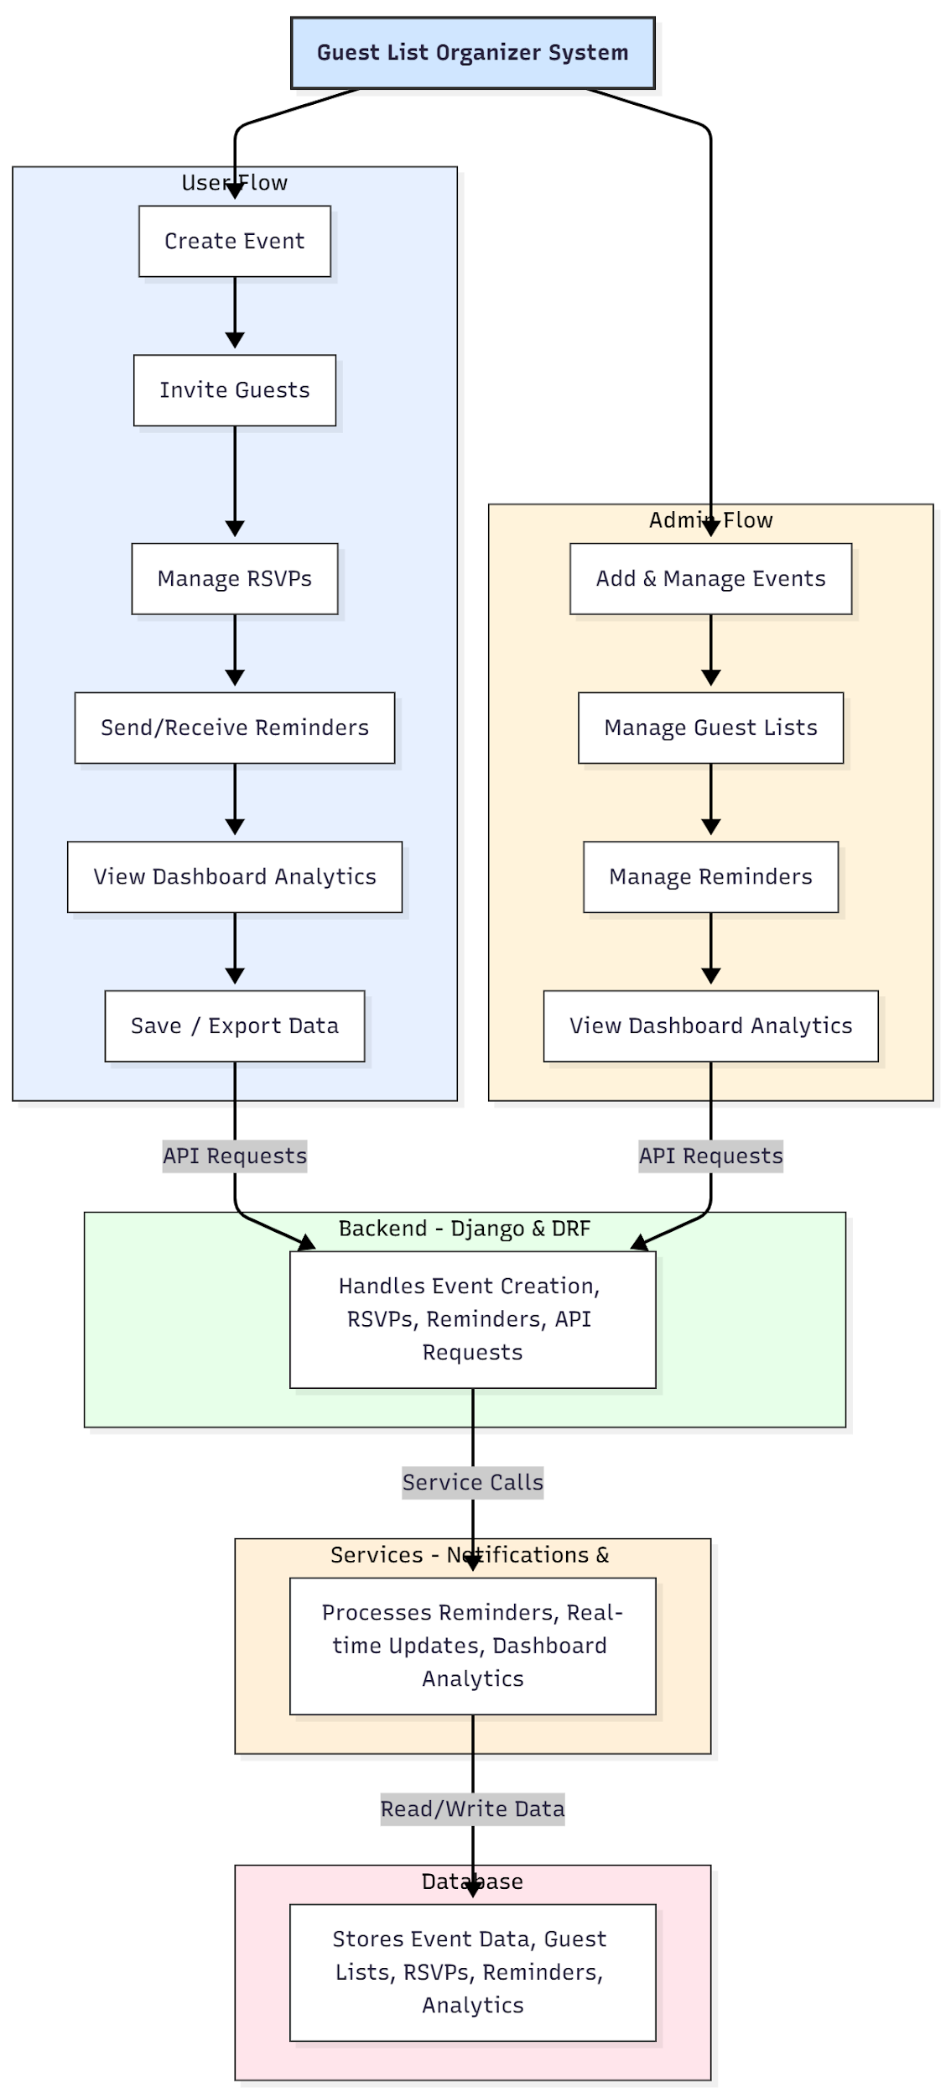

WORKING OF THE PROJECT:
Users start by creating an event and inviting guests. The backend records event details, manages RSVPs, and schedules reminders. Guests can respond to invitations in real-time, and notifications are sent automatically. Users can track attendance, monitor RSVP trends, and export guest lists or analytics reports. Administrators oversee all events, manage guest lists, reminders, and monitor system-wide analytics dashboards. The services module handles real-time notifications using socket.io and dashboard analytics, while the database stores structured data for events, guests, RSVPs, and reminders, ensuring accurate, timely, and efficient event management..

SOFTWARE REQUIREMENT:
- Backend:
  - Python 3.x
  - Django
  - Django REST Framework
  - SQLite/PostgreSQL
- Frontend:
  - Node.js and npm
  - React.js
  - Axios
- Development Tools:
  - Visual Studio Code
  - Postman (for testing APIs)
  - Git/GitHub (for version control)
- Server/Deployment (Optional):
  - Gunicorn, Nginx, or Heroku/AWS for hosting

ADVANTAGES OF THE PROJECT:

• Real-time RSVP and reminder tracking
• Automated notifications and reminders
• Centralized event and guest management
• Visual dashboards for attendance analytics
• Exportable guest lists and event reports
• Reduces manual tracking errors
• Scalable for multiple events and large guest lists
• Enhances communication and event organization

APPLICATIONS OF THE PROJECT:
• Private parties and social gatherings
• Clubs and associations
• Corporate events
• Wedding and event planners
• Schools and colleges for event management
• Community and cultural event organizers

REFERENCES:

- Django REST Framework Documentation — Django Software Foundation. Django Documentation. Available: https://docs.djangoproject.com/
- Django REST Framework. DRF Documentation. Available: https://www.django-rest-framework.org/
- React. React Official Documentation. Available: https://reactjs.org/docs/getting-started.html
- Redux. Redux Documentation. Available: https://redux.js.org/introduction/getting-started
- PostgreSQL Global Development Group. PostgreSQL Documentation. Available: https://www.postgresql.org/docs/
- MySQL. MySQL Reference Manual. Available: https://dev.mysql.com/doc/
- Git. Git Documentation. Available: https://git-scm.com/doc
- Node.js. Node.js Documentation. Available: https://nodejs.org/en/docs/
- Axios. Axios Documentation. Available: https://axios-http.com/docs/intro
- Socket.io Documentation – https://socket.io/docs/

